Identifying Translationally Active Microbes from Environmental Samples

# Purpose and objectives

## Purpose

The purpose of the procedure is to utilize the ubiquitous “hunger” of microorganisms for L-methionine, an amino acid necessary for the synthesis of proteins. In this protocol we will use a surrogate or non-canonical amino acid with an azide or alkyne functional group that will allow us to tag newly synthesized proteins in cells.

## Objective

Bioorthagonal non-canonical amino acid tagging (BONCAT) is a relatively new tool that can be paired with flow cytometry (FCM), fluorescence activated sorting (FACS), and genetic assays like Fluorescence In Situ Hybridization (FISH) to identify microorganisms from environmental samples that are actively synthesizing protein. It is advantageous because it is a relatively cheap assay that can be done in a short time frame. It is also not heavily impacted by complex organic or inorganic material that are often found in environmental samples. The objective is to use these powerful tools to be able to better our understanding of microbial activity in lakes, rivers, soils, and other environmental matrices.

# How it works

## Incubation of samples with methionine (Met) analogs

There are two possible substitutes (that are mentioned in the literature) that can be used that are a) found to be nontoxic to bacteria and b) have efficient uptake rates. These surrogates are L-azidohomoalanine (AHA) and L-homopropargylglycine (HPG). They can take the place of L-methionine in proteins with the added benefit of having either an azide (AHA) or alkyne (HPG) functional group attached to it which can be utilized to attach a fluorescent dye to the protein and “tag” it, hence amino acid tagging.

This procedure will use AHA as the amino acid for two main reasons. The first being that azide functional groups are rare Iin the environment which will help to minimize nonspecific reactions. The other reason is that AHA has a substantially lower activation rate than HPG, which makes BONCAT more readily available to react and produce measurable results. (Hatzenpichler, 2014…. I will need to add the reference later).

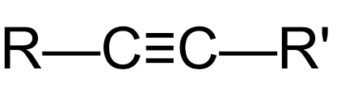

**Alkyne Functional**

**Group**

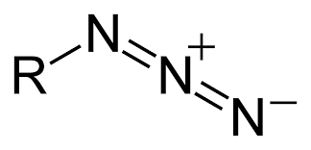

**Azide Functional**

**Group**

**L-methionine**

**L-azidohomoalanine**

**(AHA)**

**L-homopropargylglycine (HPG)**

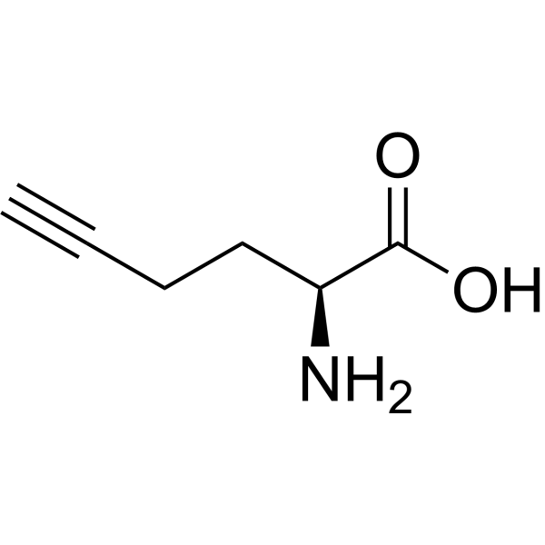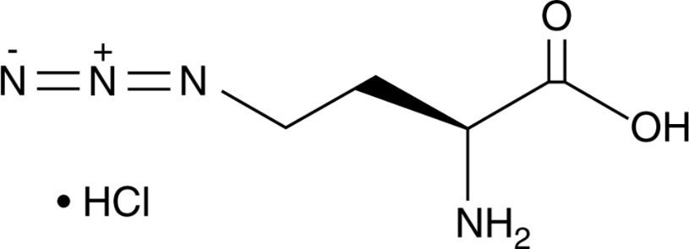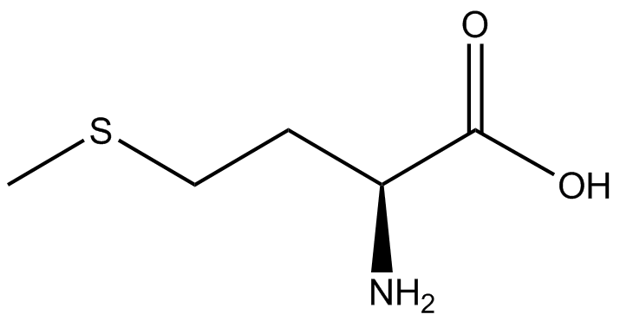

## Click Chemistry

Following incubation with the surrogate amino acids, we can use click chemistry to expedite the cycloaddition reaction between the azide and alkyne functional group with a fluorescent dye. This tags the recently synthesized proteins, containing either AHA or HPG, which we can detect using flow cytometry or FACS. The dye needs to be a be an azide conjugate (for HPG) or an alkyne conjugate (for AHA) to bind and be detected. We have two ways make this reaction happen, Copper-catalyzed Azide-Alkyne Cycloaddition (CuAAC) and Strain-Promoted Azide-Alkyne cycloaddition (SPAAC).

CuAAC uses the Cu as a catalysis to expedite the cycloaddition reaction between azide and alkyne bonds. It is best performed in an aqueous solution, can be performed over a broad temperature range (0-160 °C), and has a strong resistance to pH (4-12).

**Reaction for CuAAC**

(Himo et al., 2005)

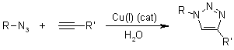

**Mechanisms for CuAAC**

(Worrell et al., 2013)

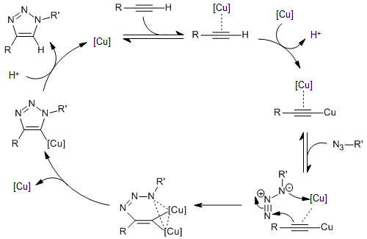

SPAAC uses the promiscuous nature of the cyclooctyne system to catalyze the same azide-alkyne reaction without the need for auxiliary chemicals to create a catalyst. This method does require an alkylating reagent to block free thiols and is limited to use with AHA. SPAAC is also has no apparent toxic traits and can be done under physiological conditions.

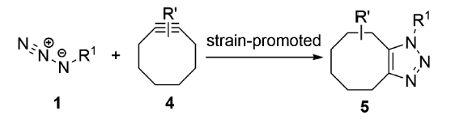

**Reaction for SPAAC**

(Yiming et al., 2022)

# Reagents and Materials

**Nanopure/MilliQ water**

Unless otherwise stated will be referred to as ultra-pure water and should be 0.2 mm filtered.

**L-azidohomoalanine (AHA)**

Stock solution made with 5 mg of AHA diluted with dimethlysulfoxide (DMSO) to 20 mM and stored between -5° C and -20° C. If stock solution needs to be replenished, dissolve 5 mg AHA in 0.968 mL DMSO.

**Tris[(1-hydroxypropyl- 1H- 1,2,3-triazol-4-yl)methyl]amine (THPTA)**

50 mM in ultra-pure water and filter sterilized (0.2 mm). Store at -20° C.

Used in click chemistry to provide a substrate for surrogate.

Chelating ligand

Helps keep Cu in its CU(I) oxidation state

**Phosphate buffered saline (PBS)**

Made in ultra-pure water and buffered to pH 7.4 before being filter sterilized (0.2 mm).

**Sodium Ascorbate**

Freshly made, 100 mM in 1x PBS. Make fresh and use the same day. This will act as a reducing agent to ensure that there is enough Cu (I) to catalyze the reaction.

**Copper Sulfate solution (CuSO4 X 5H2O)**

20 mM in ultra-pure water and filter sterilized (0.2 mm). Can be stored at room temperature or at 4° C. This will supply the Cu (I) catalyst needed for CuAAC.

**Aminoguanidine hydrochloride**

100 mM in 1x PBS and made fresh each time. Inhibits protein cross-linking and precipitation

**Ethanol (EtOH)**

Make a 96% EtOH solution and use it the same day. We will dilute this to 50% and 80% EtOH later.

**Carboxyrhodamine 110 alkyne (C-110)**

Prepare a 10 mM standard solution of C-110 in DMSO. If this needs to be replenished, dissolve 1 mg of C-110 in 0.170 mL of DMSO.

**P-1000 pipette and tips**

**P-20 pipette and tips**

**2 mL microcentrifuge tubes**

Label with site ID and whether it is a Live (L), Kill (K), or Control (C).

# Procedure

## Incubation of sample with methionine surrogate

1. Using a p-1000, aliquot 1.485 mL of your sample into the 2 mL microcentrifuge tube marked for live samples. Pipette 1.5 mL of sample into the tubes labeled for kills and controls.
2. Add 15 uL of 10 mM AHA to the test tube containing sample. Pellet the kills via centrifugation and resuspend in 1:1 PBS : EtOH and incubate the kills.
   1. Incubate the live samples at 20° C for 2 hours
   2. Incubate control samples at 20° C for 2 hours.
   3. Incubate kill samples at 4° C for 2 hours
3. Pellet the lives and controls via centrifugation and resuspend in 1:1 PBS : EtOH. Pipette 1.485 mL of ultra-pure water and 15 uL of 10 mM AHA into the tubes labeled as kills. Incubate the lives, controls and kills.
   1. Controls and lives incubated at 4° C for 2 hours
   2. Kill samples incubated at 20° C for 2 hours
4. Pellet the samples once more and resuspend in 1 mL of 1:1 PBS : EtOH and store samples at -20° C or continue onto click chemistry step.

## Click Chemistry

1. Dehydrate and permeabilize cells
   1. Resuspend in 50% EtOH (dilute in tube with ultra-pure water) and vortex to mix
   2. Centrifuge at 14,000 xg for 5 min
   3. Repeat a and b with 80% and 96% EtOH
   4. Finally resuspend in 221 mL of 1x PBS (do not need to remove small volumes of EtOH because it does not interfere with the click chemistry)
2. Prepare dye premix by pipetting 3.0 mL of 5 mM CuSO4 solution, 15 mL of 50 mM THPTA, and 1.5 mL of 5 mM C-110 dye. Allow premix to react for 3 min @ RT in the dark
3. While the dye premix is reacting add 75 mL of 100 mM sodium ascorbate and 100 mM aminoguanidine and 330.5 uL of DMSO to the sample tubes.
4. Add the dye premix to the samples and invert once to mix (DO NOT vortex! This will mix oxygen into the sample and compromise reduction conditions) and incubate the sample for 30 minutes @ RT in the dark
5. After incubation
   1. Wash 3 times with PBS
   2. 1 additional time with 50% EtOH
   3. Centrifuge between washes for 5 min at 14,000 xg
6. Resuspend in 1:1 mix of PBS:EtOH. Vortex to mix

## glyTE cryopreservation for JGI single cell DNA analyses.

glyTE stock preparation

* Combine 20 mL 100x TE (pH 8.0). 60 ml ultra-pure water, and 100 mL molecular grade glycerol.
* Filter the glyTE solution through a 0.2 um Acrodisc and refrigerate. Re-filter monthly.

Preservation

* Transfer 100 uL of glyTE and 1 mL of sample into a cryovial and mix gently. Incubate for ~5 minutes at room temperature.
* Store at -80° C.